 | GSD Management  Technical Design Document  Version 1.0
   | Prepared By / Last Updated By | Prepared By / Last Updated By | Prepared By / Last Updated By | Prepared By / Last Updated By | Prepared By / Last Updated By
  Name | Vijay Anand | V. Gnaneshwari | A.Ishwarya | Ramya Venkateshwaran | S. Santhoshi
  Role | Team Member | Team Member | Team Member | Team Member | Team Member
  Date | 28/05/2019 | 28/05/2019 | 28/05/2019 | 28/05/2019 | 28/05/2019
Table of Contents

1.0 Introduction 4
1.1 Purpose of this document 4
1.2 Scope 4
1.3 Intended Audience 4
1.4 Definition & Acronyms 4
2.0 Conventions and Standards Followed 5
3.0 Assumptions, Dependencies and Risks 5
3.1 Assumptions: 5
3.2 Dependencies: 5
4.0 Schematic Diagram 5
5.0 Use Case Realization 7
5.1.1 User/Admin Login 7
a. Functional Requirement 7
b. UI Validations 7
c. UI Controls 8
d. UI Methods Definition 9
5.1.2 User/Admin Registration 10
a. Functional Requirement 10
b. UI Validations 10
c. UI Controls 10
d. UI Method Definition 11
e. UI Design 12
5.1.3 Admin Tasks 13
a. Functional Requirement 13
b. UI Validations 13
c. UI Controls 14
d. UI Methods Definition 15
e. UI Design 16
5.1.4 User Tasks 17
a) Functional Requirement 17
b) UI Validations 17
c) UI Controls 18
d) UI Methods Definition 18
e) UI Design 19
6.0 Database Design 20
a. Data Model 20
The following is a schematic view of the database design 20
b. Tables Structure 20
i. Table 1.0(Admin) 20
ii. Table 2.0(User) 21
6.1.3 Table 3.0(GSD) 21
6.1.4 Table 4.0(Notification) 22

Introduction

Purpose of this document
The purpose of the detail design document is to define the detailed design for all the components of GSD Management system specified in the Business Requirement/Use case document. All the low-level components, interfaces and integrations are explained in this document.

Scope
This sub-section shall state the scope of this detailed design document
- Create and maintain user information.
- Manage GSD.

Intended Audience
The intended audience for this document are
- Developers, testers, other associates in the project
- Technical lead, Scrum Master
- Product Owner

Definition & Acronyms
Acronyms | Definitions
GSD | Global Service Desk
GMS | GSD Management System
BRD | Business Requirement Document

Conventions and Standards Followed
The modules under scope needs to adhere to the coding standards and guidelines.

Assumptions, Dependencies and Risks

Assumptions:
- Once the application is built, the GMS will manually load the lists into the system.
- There will be no concurrent users for the application.
- Any changes to the design mentioned in the BRD would be taken as a Change Request.

Dependencies:
- Availability of database design characteristics & access.
- Resource availability throughout each of the sprint.

Schematic Diagram
A schematic, or schematic diagram, is a representation of the elements of a system using abstract, graphic symbols rather than realistic pictures. It gives an overview of overall system

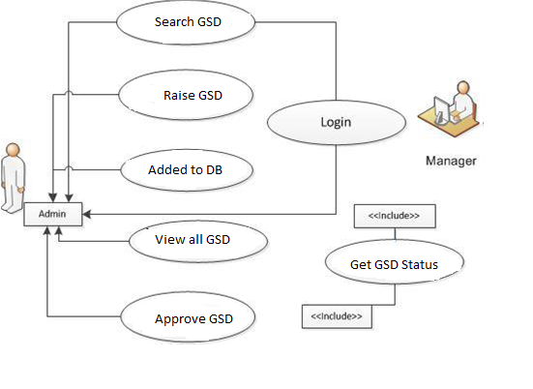

Use Case Realization

User/Admin Login

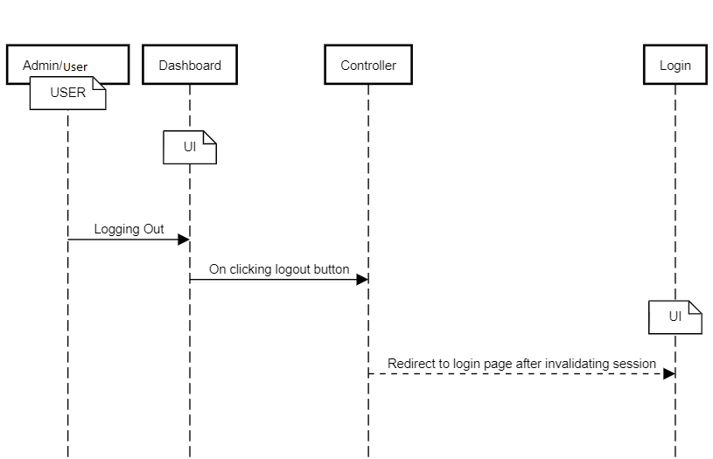

Functional Requirement
. Login Page checks the authentication of the user and based on his role, directs the user to the respective page. User is provided with searching, raising and viewing GSDs. Admin is provided with viewing and releasing all Users GSDs.

UI Validations
- User/Admin Id and Password fields are mandatory.
- Invalid Id and / or password should not allow the user to get into the system.

UI Controls
- User Login
# | UI Component | Type | Name | Details
2 | employeeId | Text field | Textfield_user | To enter user identification number
4 | employeePassword | Text field | Textfield_password | To enter password
5 | Login | Button | Login | Button to submit login details and login to system

- Admin Login
# | UI Component | Type | Name | Details
2 | adminId | Text field | Textfield_user | To enter user identification number
4 | adminPassword | Text field | Textfield_password | To enter password
5 | Login | Button | Login | Button to submit login details and login to system

UI Methods Definition
Method Name | Details
Login | Allows the user to login into the GSD portal.

User Registration
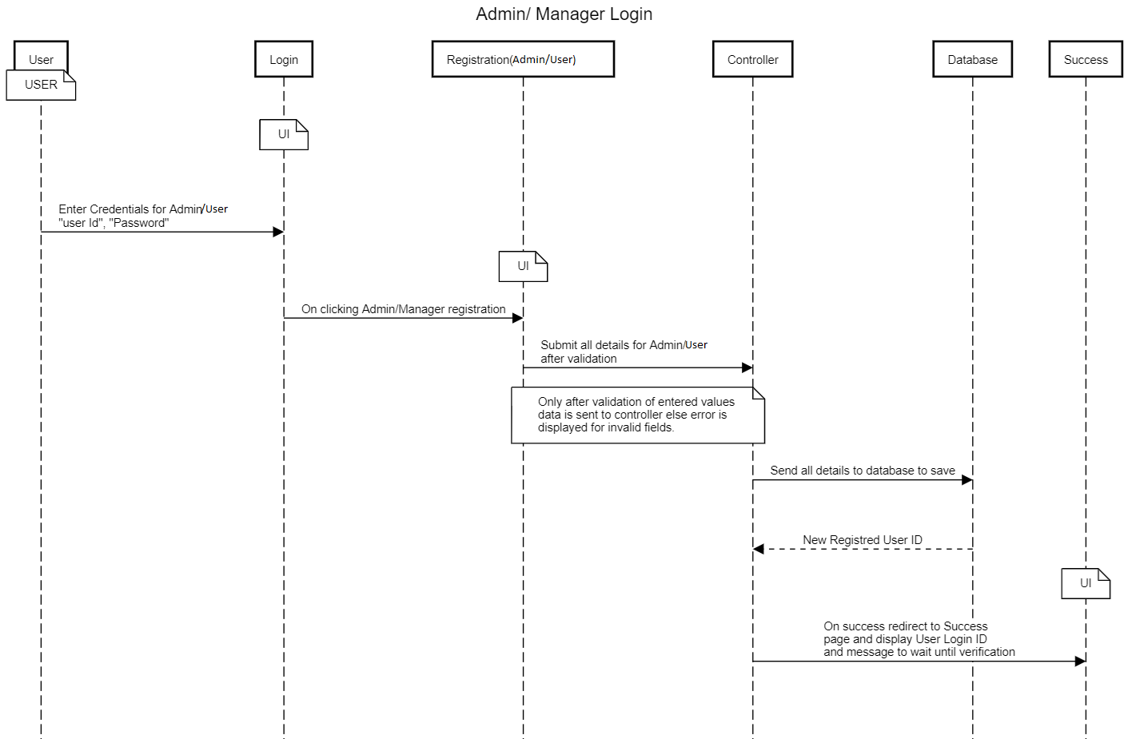

Functional Requirement
From login page if user selects register option, registration form for user and admin will appear in new page for selected option. User will be able to fill the details and register.

UI Validations
- All the fields are necessary.
- Invalid entries and empty fields are not accepted.

UI Controls
- User Registration
# | UI Component | Type | Name | Details
1 | ID | Label | Label_for_user_fid
2 | employeeId | Text field | Textfield_for_id | To enter ID
3 | First Name | Label | Label_for_user_first_name
4 | employeeFirstName | Text field | Textfield_for_firstname | To enter First name
5 | Last Name | Label | Label_for_user_last_name
6 | employeeLastName | Text field | Textfield_for_lastname | To enter Last name
5 | Age | Label | Label_for_user_age
6 | employeeAge | Text field | Textfield_for_age | To enter age
7 | Gender | Drop down | Dropdown_for_Male_and_Female | To select gender
 | Contact | Label | Label_for_number
 | employeeNumber | Text field | Textfield_for_number | To enter number
 | Address | Label | Label_for_address
 | employeeAddress | Text field | Textfield_for_address | To enter address
 | City | Label | Label_for_city
 | employeeCity | Text field | Textfield_for_city | To enter city
 | Zipcode | Label | Label_for_zipcode
 | employeeZipcode | Text field | Textfield_for_zipcode | To enter Zip code
 | Password | Label | Label_for_password
 | employeePassword | Text field | Textfield_for_password | To enter Password
3 | Sign Up | Button | Submit | Button to submit details entered

- Admin Registration
# | UI Component | Type | Name | Details
 | ID | Label | Label_for_user_fid
 | adminId | Text field | Textfield_for_id | To enter ID
 | First Name | Label | Label_for_user_first_name
 | adminFirstName | Text field | Textfield_for_firstname | To enter First name
 | Last Name | Label | Label_for_user_last_name
 | adminLastName | Text field | Textfield_for_lastname | To enter Last name
 | Age | Label | Label_for_user_age
 | adminAge | Text field | Textfield_for_age | To enter age
 | Gender | Drop down | Dropdown_for_Male_and_Female | To select gender
 | Contact | Label | Label_for_number
 | adminNumber | Text field | Textfield_for_number | To enter number
 | Password | Label | Label_for_password
 | adminPassword | Text field | Textfield_for_password | To enter Password
 | Sign Up | Button | Submit | Button to submit details entered

UI Method Definition
Method Name | Details
Sign Up | Allows the user to submit user details

UI Design
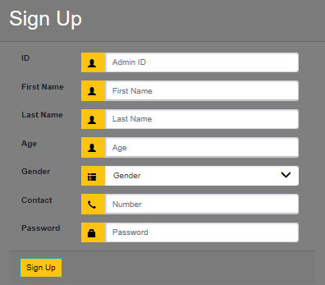

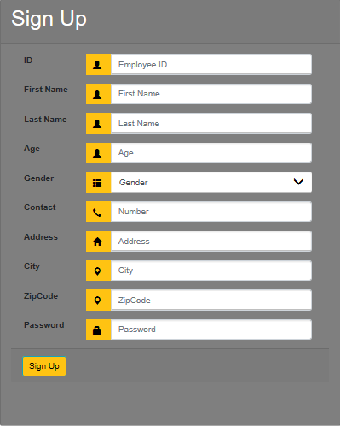

Admin Tasks
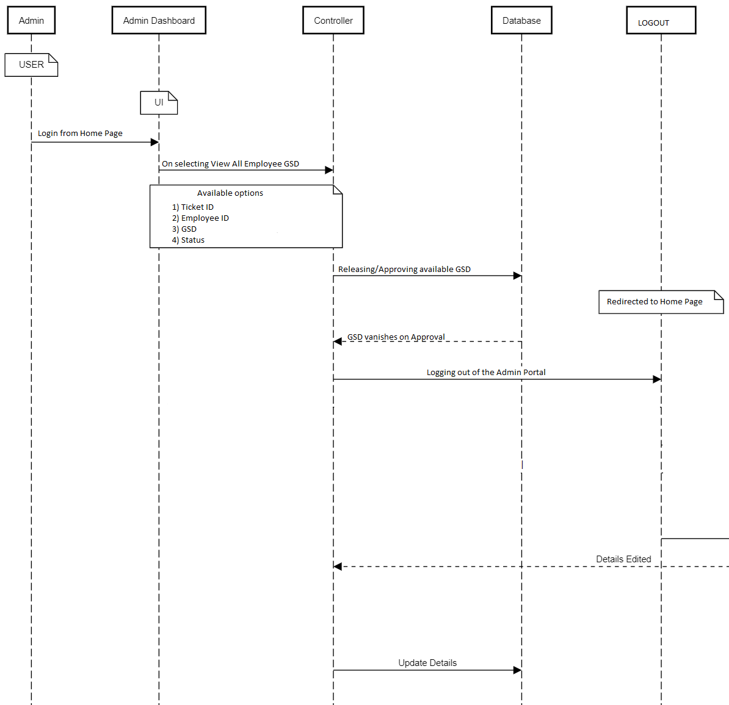

Functional Requirement
Admin Dashboard contains a button ‘View all Employee GSD’ for admin to perform tasks like view all GSDs of all users, release/approve those GSDs. In addition, there is a logout button redirected to Login page.

UI Validations
- No Validations required here.

UI Controls
# | UI Component | Type | Name | Details
1 | View All Employee GSD | Button | viewGSD | To view all the GSD raised by every User.
2 | Approve | Button | approveGSD | To release a raised ticket.
3 | Back | Button | Back | To go back to previous page.
4 | Logout | Button | Logout | To log out of the system.

UI Methods Definition
Method Name | Details
AllGSD_click | Allows the admin to view all users GSD
ApproveGSD_click | Admin can release the selected GSD
Home_click | Go to admin dashboard
Logout_click | Logout of the system.

UI Design
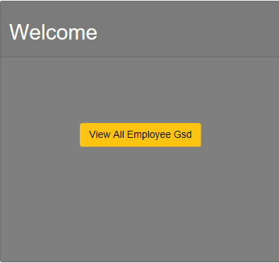

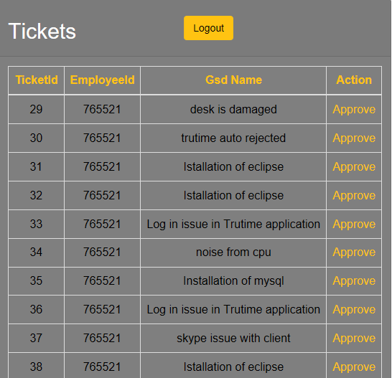

User Tasks
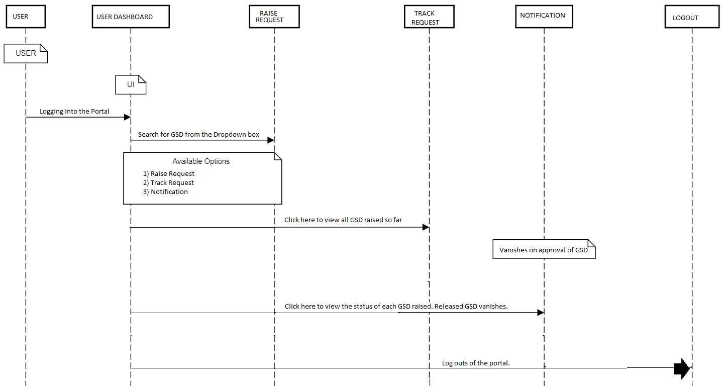

a. Functional Requirement
User Dashboard contains all the buttons for user to perform different tasks like searching GSD, raising GSD, viewing history of all GSD, viewing details of GSD and gets redirected to respective pages. In addition, there are logout buttons on all the pages.

UI Validations
- Drop down for selecting GSD is mandatory.

UI Controls
# | UI Component | Type | Name | Details
1 | GSD | Button | homeGSD | Welcome page with user name.
2 | Raise Tickets | Button | raiseGSD | Redirects to search GSD page with dropdown to select GSD.
3 | Track GSD | Button | trackGSD | To view all the GSD raised so far.
4 | Notification | Button | notification | To view Status of GSD raised.
5 | Logout | Button | logout | To logout from the GSD portal.

UI Methods Definition
Method Name | Details
GSD_click | Displays user details.
RaiseTickets_click | Redirect to GSD search Engine.
TrackGSD_click | Redirects to a page with track of all GSDs.
Notofication_click | Redirects to a page with status of every raised GSD.
Logout_click | Logs out of the portal.

UI Design
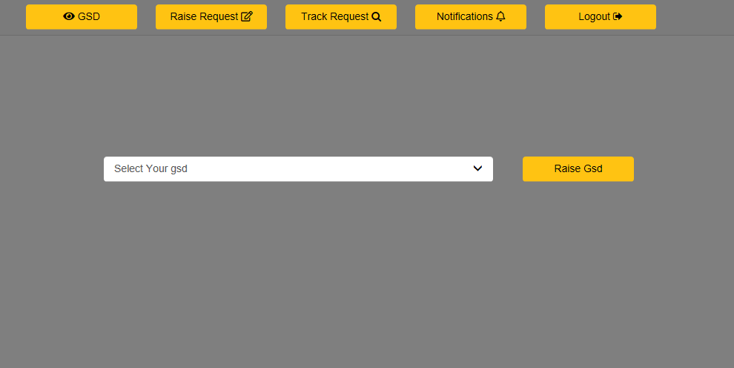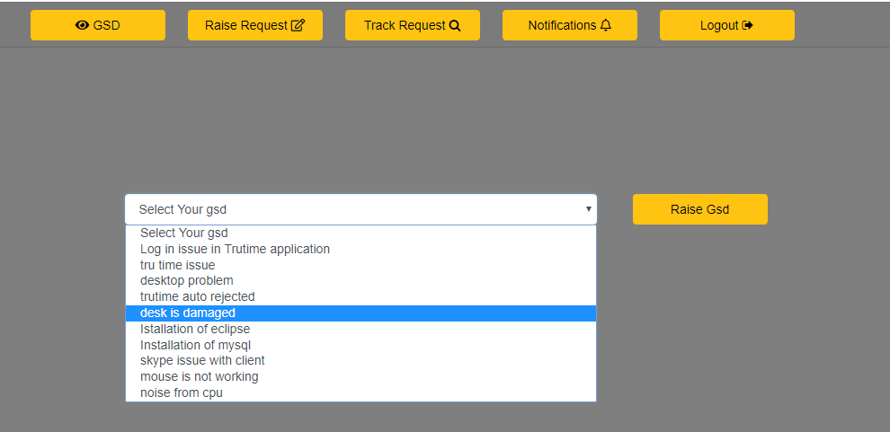

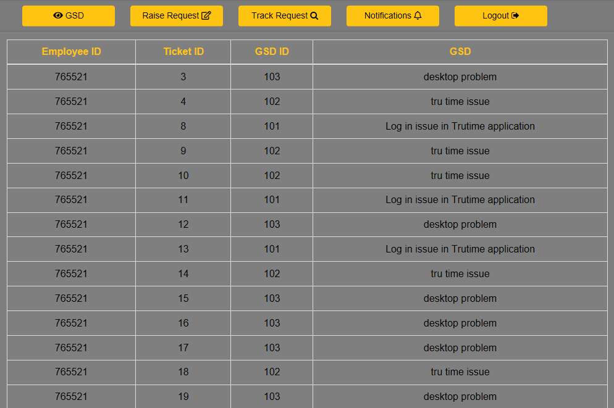
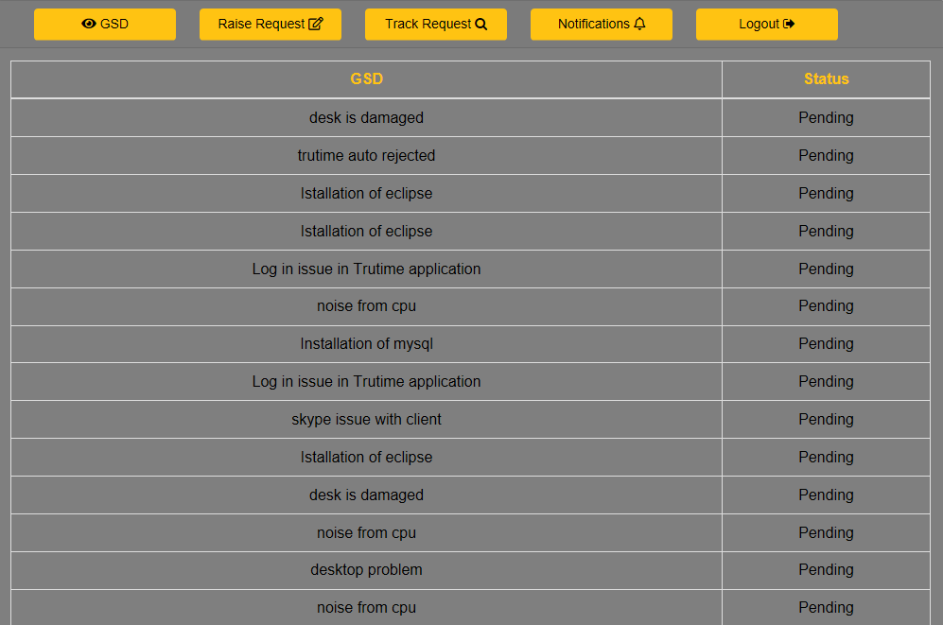

Database Design

Data Model

The following is a schematic view of the database design
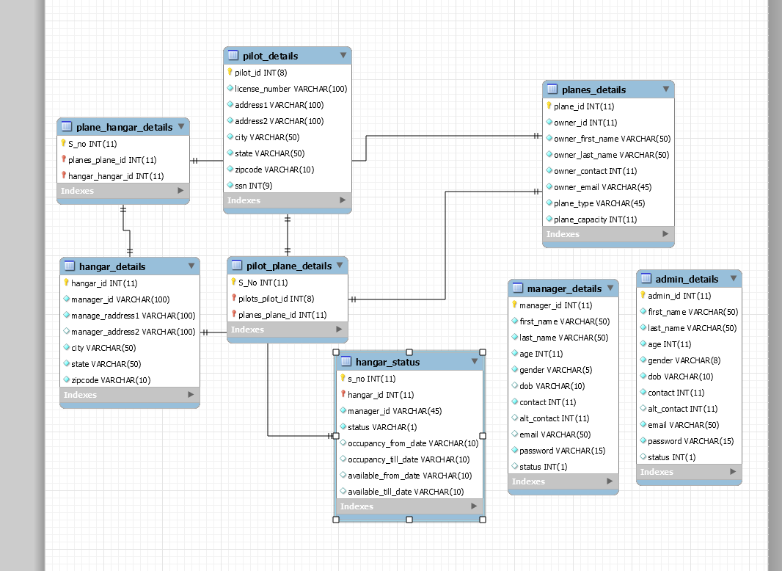

Tables Structure

Table 1.0(Manager)
Field Name | Field Type | Data Type | Mandatory | Possible Values
Admin First Name | Text(50) | Alphabetic | Yes
Admin Last Name | Text(50) | Alphabetic | Yes
Age | Numeric(2) | Numeric | Yes
Gender | Drop Down | NA |  | Male, Female
Contact Number | Text(10) | Numeric | No
AdminId | Text(15) | Alphanumeric | Yes
Password | Text(15) | Alphanumeric | Yes

Table 2.0(Admin)
Field  Name | Field Type | Data Type | Mandatory | Possible Values
User First  Name | Text(50) | Alphabetic | Yes
User Last Name | Text(50) | Alphabetic | Yes
Age | Drop Down | NA | Yes | 18-120
Gender | Drop Down | NA |  | Male, Female
Contact Number | Text(10) | Numeric | No
Address | Scrolling text box(100) | Alphanumeric | No
City | Text(50) | Alphabetic | Yes
Zip Code | Text(10) | Numeric | Yes

Table 3.0(GSD)
Field  Name | Field Type | Data Type | Mandatory | Possible Values
GSD Name | Text(50) | Alphabetic | Yes
GsdId | Numeric(20) | Numeric | Yes

Table 4.0(Notification)
Field Name | Field Type | Data Type | Mandatory | Possible Values
NotificationId | Text(50) | Alphabetic | Yes
NotificationType | Text(50) | Alphabetic | Yes
NotificationText | Text(50) | Alphabetic | Yes | 18-120

